**Programming**

Build a simple Media App VOD (Video On-Demand) application that keeps track of a list of videos the user has watched. You may use this API for a video list <https://demo2697834.mockable.io/movies>

Application Features

1. Application should display a list of videos in a horizontal carousel on the home page which can be scrollable.
2. User should be able to select a video to play in full screen.
3. When the video is finished, the application should go back to the previous page.
4. The user should be able to use a mouse and keyboard to select the video.
5. The user should be able to see a list of videos they have previously watched.
6. The application must be responsible to changing screen sizes. You do not need to implement a mobile view but it should at least adjust based on the desktop browser width.

# Prerequisites

* The app should work in the latest version of Chrome Browser
* The app is suggested to be developed entirely in (X)HTML/JavaScript/CSS, as a **single page application** (<https://en.wikipedia.org/wiki/Single-page_application>)
* The viewing history should be saved on a server and persisted across browsing sessions. That is, if the user refreshes the browser the history should be automatically loaded. User authentication is not necessary.
* The server is suggested to be developed in either NodeJS, NoSQL, PHP, MySQL
* Data between the server and client side should be in JSON format.
* Applicants are required to use **JavaScript** to complete the test. Detailed instructions about how to set up the app and server is required. A live demo hosted on a publically accessible server is highly regarded, for example AWS, Heroku, OpenShift
* If you are using any cloud solutions to host or develop your application, credential(s) should be provided.
* The app should be controllable by the arrow keys (to navigate) and enter (to select), and mouse.
* The app should follow the design template illustrated on the next page Suggested tools (but not required):
  + Chrome Developer Tools (for debugging)
  + Frameworks such as JQuery, Express, Angular, Bootstrap, Sass/Less
  + Build tools such as Grunt, Gradle

# Delivery

Your implementation of Media App should be delivered in a compressed archive or Github containing all necessary files and resources. Also, an instruction on how to install and start the app is expected, preferably in a ReadMe.

# Useful Resources

Playback Icons:

<https://fortawesome.github.io/Font-Awesome/icons/>

Movies API:

<https://demo2697834.mockable.io/movies>

OpenShift:

<https://www.openshift.com/>

# Suggested Structure

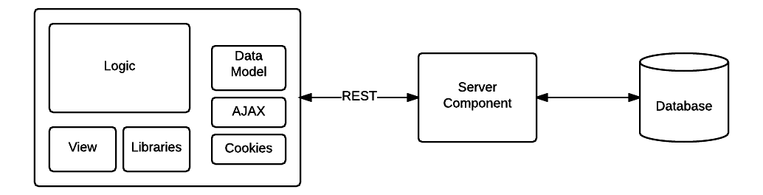

# UI

Landscape:

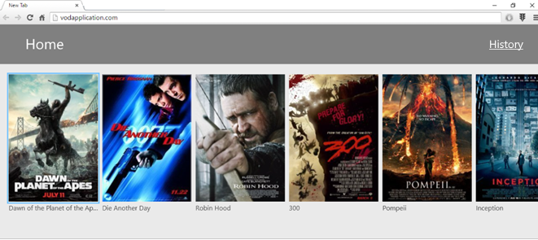

Player:

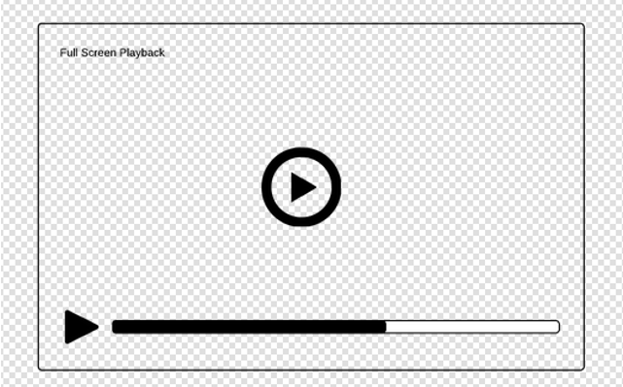

Portrait (Optional):

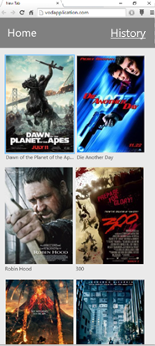

# Marking Scheme

Points out of 10

* Coding Style (4)
* Proper use of well-known Frameworks and/or Modern Technology (1)
* Answered the Question/Meet the requirements (1)
* Documentation (1)
* Deployment/Setup/Hosting (1)
* Creativity (2)

# Design Question

At Accedo, our developers are involved throughout the entire product development process; from pre-sales all the way to go-live. Imagine you’re a developer on a VOD project that allows users to save the videos they want to watch later.

1. Describe the data you would capture as part of this service.
2. How would make this service more efficient?
3. Once the feature is complete, how would you know that it’s ready for go-live?
4. How would you determine if this feature is successful?